Chemical composition of RAFM steel (in wt. %)

|  |  |  |  |  |  |  |  |  |  |  |
| --- | --- | --- | --- | --- | --- | --- | --- | --- | --- | --- |
| **Element** | **Cr** | **C** | **Mn** | **V** | **W** | **Ta** | **N** | **O** | **P** | **S** |
| **wt.%** | 9.04 | 0.08 | 0.55 | 0.22 | 1.01 | 0.06 | 0.0226 | 0.0057 | 0.002 | 0.002 |
| **Element** | **B** | **Ti** | **Nb** | **Mo** | **Ni** | **Cu** | **Al** | **Si** | **Co** | **As +Sn+ Sb** |
| **wt.%** | 0.0005 | <0.005 | 0.001 | 0.001 | 0.005 | 0.001 | 0.004 | 0.09 | 0.004 | <0.03 |

Balance: **Fe**

Hardness tests:

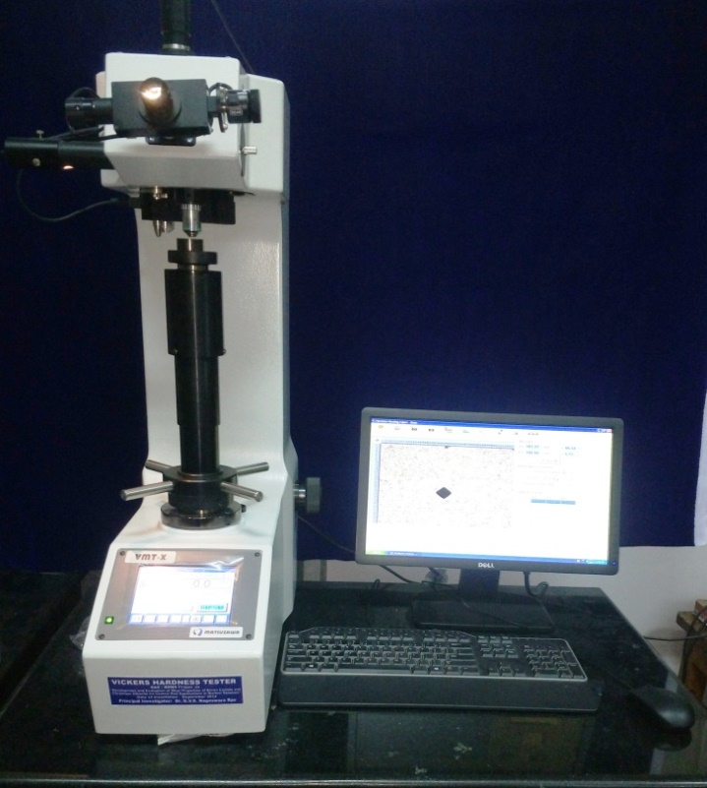

Macro Vicker’s (Make: Matsuzawa, Model: VMT-X7)

Hardness Values:

|  |  |
| --- | --- |
| Material Condition | Hardness Values |
| N+T | 206 |
| TMT- Hot rolled | 365 |
| TMT- Hot rolled+ Tempred | 222 |

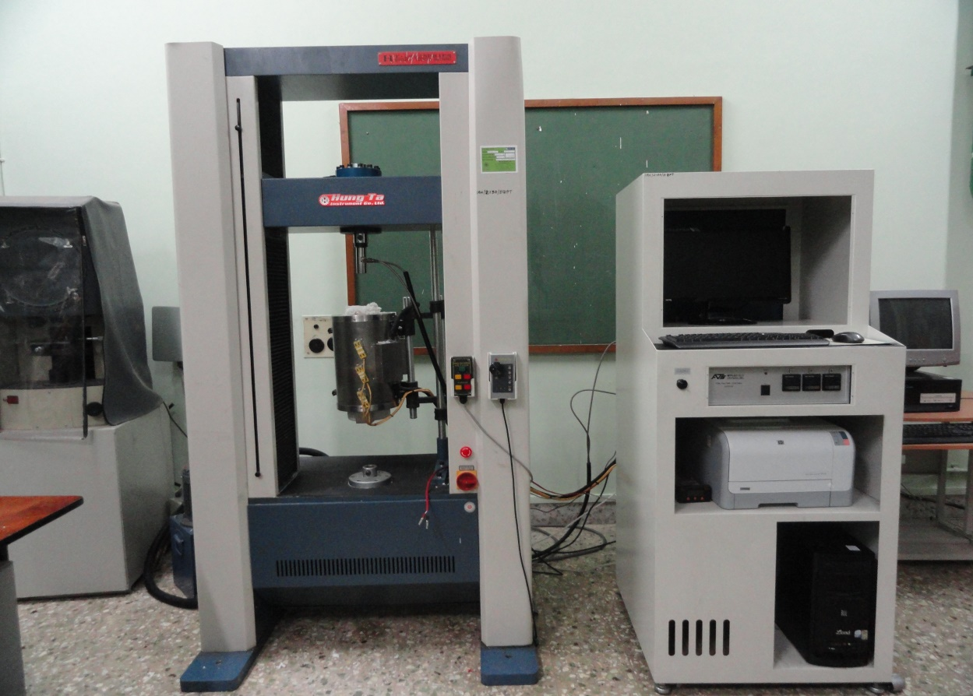

Hung-Ta tensile testing machine for room and high temperature tensile studies (Model: HT-2402, capacity: 10 ton)

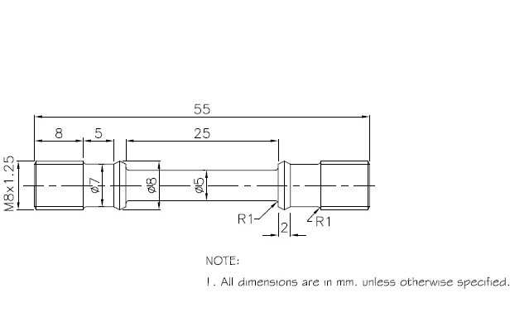

Schematic of standard tensile test specimen (as per ASTM E8M)

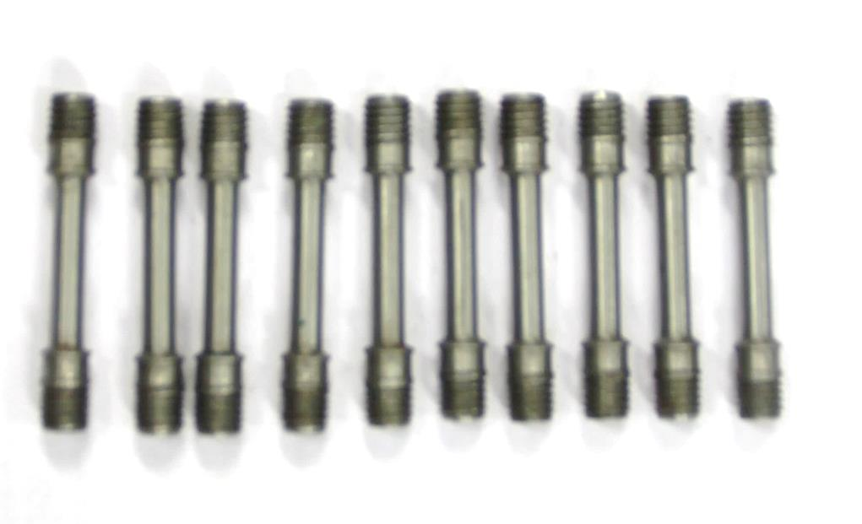

Fabricated Tensile samples as per the ASTM E8M





Tensile curves of RAFM steel at different test temperatures at strain rate of 3×10-4 s-1 for **(a)** N+T and **(b)** AF-TMT25 conditions.